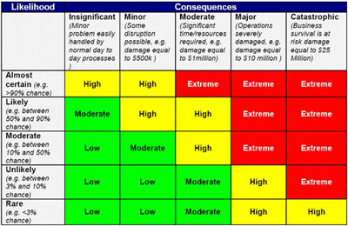

Name of Event: | Event Organiser:
Prepared by: | Date Prepared
Responsible Person (at event): | Date of Event and Duration:

Risk/Hazard details | Likelihood | Consequence | Risk Rating | Action to control Risk | Person Responsible | Time Frame
People

Trip Hazards

Risk/Hazard details | Likelihood | Consequence | Risk Rating | Action to control Risk |  | Person Responsible
Health

Hazardous Material

Technical Management

Risk/Hazard details | Likelihood | Consequence | Risk Rating | Action to control Risk |  | Person Responsible
Vehicular & Pedestrian

Waste

Accessibility

Event/ Site Specific Risks

Examples of Risk – Please note that below are some examples of risks and hazards that may be considered when organizing an event and are not exhaustive. These risks act as a prompt to assist you in indentifying your risks and hazards. Site specific or event specific risks need to be considered and/or identified.

People | Trip Hazards | Health | Hazardous Materials
Disorderly behaviour | Electrical cables | Food Poisoning | Chemical Hazards
Public Accessing Non-public areas of event | Uneven ground and/or loose surfaces | Animal to human spread of disease | Pyrotechnics/Fireworks
Drug and/or alcohol affected persons | Flooring design/ surfaces | Disease Outbreak | Fuels i.e. Petrol, LPG, Diesel
Criminal activity | Lighting | Excessive noise levels
Misuse of amusement or rides | Climbing for vantage points | Dehydration
Over crowding | Temporary Fencing | Sunburn
Terrorism/bomb threat |  | Needles/syringes
Medical emergency (i.e. heart attack) |  | Inadequate maintenance of toilets
Lost Children |  | Inadequate use of toilets
Water Hazard (i.e. drowning)
Lack of awareness of facility locations

Technical Management | Vehicular & Pedestrian | Waste | Accessibility
Inadequate Site Management | Disabled Parking | Insufficient rubbish bins | Inadequate seating space
Lack of Staff Briefing | Lack of Parking Spaces | Inadequate emptying/cleaning of bins | Inaccessible toilet facilities
Communication failure | Traffic Congestion | Litter collection | Accessibility for persons with disabilities
Power Failure | Collisions | Collection/removal of wastewater
Water Failure | Emergency Services Access | Wastewater Spill
Toilet Failure | Pedestrian walkways | Site clean up
Unregistered Food vendors
Unsafe temporary structures
Extreme Weather
Electrocution
Fire

